Performance Pro
Appraiser
Training
Appraiser
Training
Table of Contents
Objectives 4
During the Training 4
Appraisal Overview 5
Appraisal 6
Appraisal Process with a Self-Evaluation 6
Completing an Appraisal 6
Navigation & Menus 7
OBJECTIVE Basics: 8
Adding Objectives to an Employee’s Appraisal 8
Adding a OBJECTIVE 8
Copy a OBJECTIVE 9
9
Admin a OBJECTIVE 10
Using My Library (if applicable) 11
Evaluate Critical Behaviors 13
Evaluate Objectives 14
Summary Comments 15
Finish Appraisal 15
Ready 15
The Appraisal Meeting 16
Complete 16
Completing an Appraisal 17
E-Signature 18
Widgets & Buttons 19
Widgets 19
Buttons 19
Performance History 20
Appraisals 20
Adding Notes 20
Additional Documents 22
Wrapping Things Up 23
Objectives 23

Objectives
In the Performance Pro Appraiser Training, we will log into Performance Pro as an Appraiser. By the end of the training, you will understand how to complete an appraisal using Performance Pro. The key objectives for this training include:
  - Identify the steps of the Appraisal Process
  - Demonstrate the process of completing an appraisal in Performance Pro
  - Discuss how to complete comments on an appraisal
  - Discover the Performance History
  - Adding Objectives
  - E-Signing an Appraisal

During the Training
Using the Got Training toolbar located to the right of your screen you can raise your hand or send a chat message to the trainer.

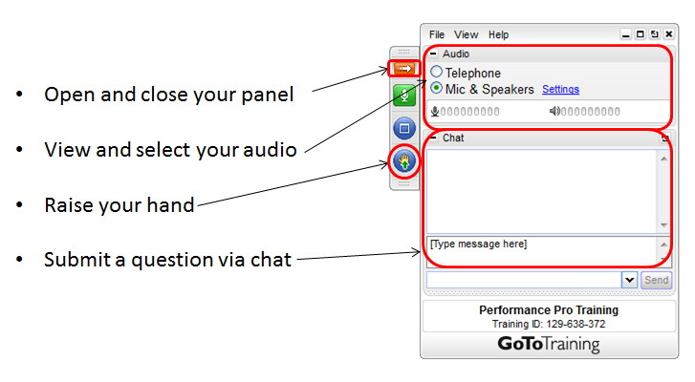

Appraisal Overview

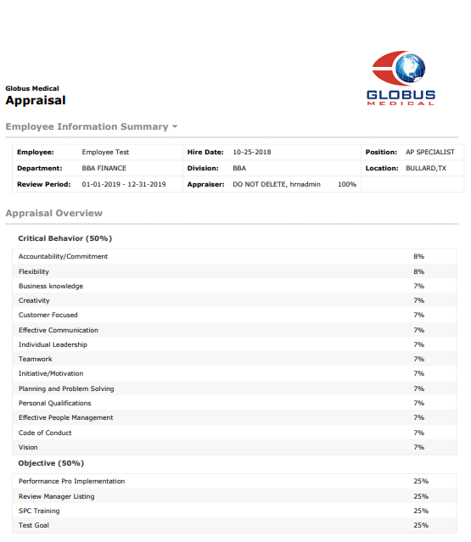

Appraisal

Appraisal Process with a Self-Evaluation

Completing an Appraisal
An Appraiser can complete an Appraisal in 5 easy steps.

- Evaluate Competencies: Evaluate assigned Competencies, provide a numerical rating and add comments.
- Evaluate Objectives: Evaluate previously established Objectives (if applicable), provide a numerical rating and add comments.
- Add New (Future) Objectives: Establish new Objectives for the current or future appraisal period.
- Summary Comments: Complete Summary Comments section as required by your organization.
- Finish Appraisal (Mark Ready, Merge, Route, & Complete): Mark the appraisal as Ready. Merge the employee’s self-appraisal with the appraiser’s evaluation and Complete the appraisal.

APPRAISER: The action of Marking Ready for the Appraiser starts the finishing steps for the appraisal. The manager will still can edit the appraisal until it has been marked complete.

Navigation & Menus
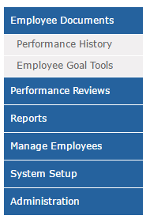
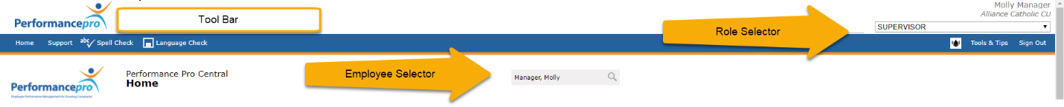

Tool Bar. Used to navigate the system. It gives you access to Save, Spelling, Help and your employee selection menu.
Menu. Gives you access to the different system features including the Appraisal.
Role Selector. Ensures you have access to the features needed to complete an Appraisal.
Employee Selector. Use to select an employee

Setting Objectives Using Performance Pro

OBJECTIVE Basics:
- Objectives will cycle from one Appraisal cycle to the next; i.e.: Future Objectives cycle to become Current Objectives
- OBJECTIVE Weight must equal 100%
- Current Objectives - Evaluated in current evaluation period
- Future Objectives – Set for the next evaluation cycle
- Action Items – Steps that employees should accomplish to achieve all aspect of an OBJECTIVE
- Consider setting Objectives that are SMART (Specific, Measurable, Attainable, Relevant, and Timely).

Adding Objectives to an Employee’s Appraisal
Performance Pro provides 4 ways to add Objectives to an employee’s Appraisal:

- Add an OBJECTIVE
- Copy an OBJECTIVE from one Appraisal cycle to the next
- Admin an OBJECTIVE
- Use the OBJECTIVE Library

Adding an OBJECTIVE
When do I use this?
- When an OBJECTIVE is applicable to an individual employee
- When an OBJECTIVE is applicable to multiple staff, but changes are not applied globally
How do I use this function?
- From the main menu, under Employee Documents, click Employee OBJECTIVE Tools.
- The Current Objectives tab will display. Click the Future Objectives tab if desired.
- Click the Add New Button.
- Enter a new OBJECTIVE name in the Name box. For easy viewing of the titles, keep them brief.
- Enter a weight and due date
- Enter a detailed description of the OBJECTIVE in the Description box.
- Add Milestones, if required.
- Click Spelling and/or Language Check and Save
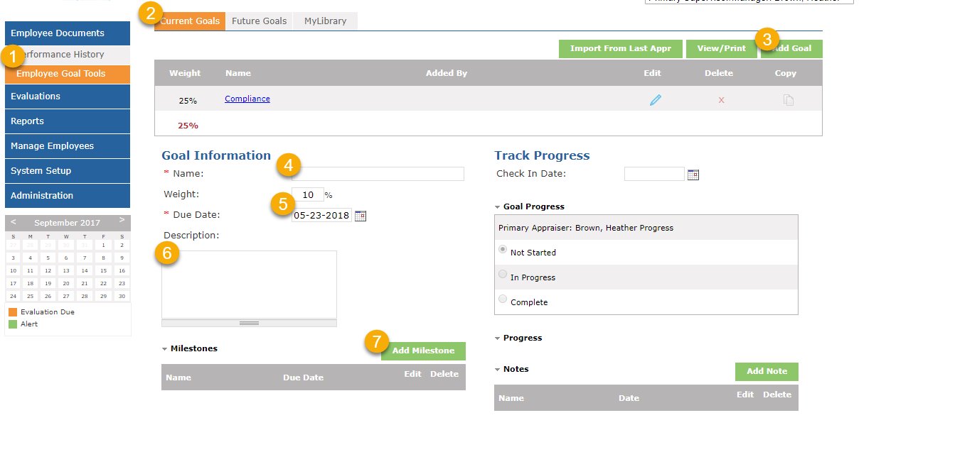

Copy an OBJECTIVE
When do I use this?
- When an OBJECTIVE is applicable in the next Appraisal cycle

How do I use this function?
- Select Employee OBJECTIVE Tools
- Select the OBJECTIVE to copy
- Select Copy Button
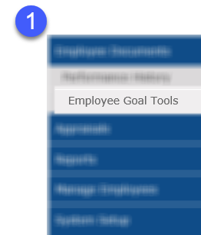

Admin an OBJECTIVE
When do I use this?
- When an OBJECTIVE need to be copied to other team members, but will not require global editing

How do I use this function?
- Select Employee OBJECTIVE Tools
- Select the OBJECTIVE to Admin
- Select Admin button
- Select Period to Admin
- Select Employees to Admin OBJECTIVE
- Select Save

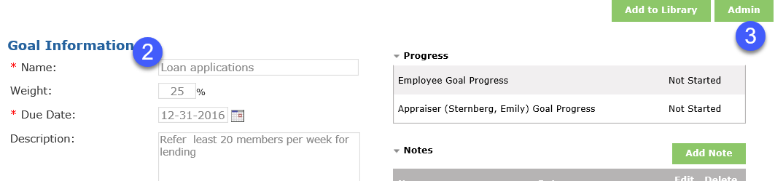
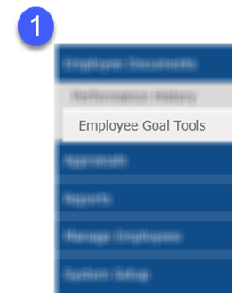

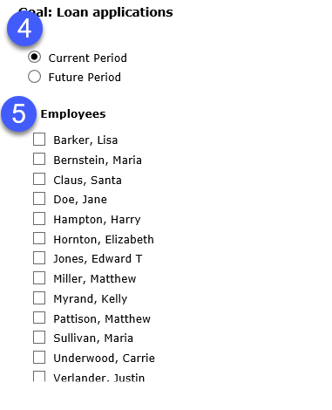

Using My Library (if applicable)
When do I use this?
- When an OBJECTIVE will be used frequently in employee appraisals

To assign a Company OBJECTIVE:
- From the main menu, click Employee OBJECTIVE Tools/My Library.
- Click on the OBJECTIVE Library tab.
- Click on My Objectives or Shared Objectives
- From the Available Objectives dropdown list, click the down arrow and select the OBJECTIVE you wish to assign. (To see all Objectives, regardless of category, click Show All.)
- Click Assign to Employees below the Action Steps section.
- In the Assign section, click the Add button.
- Click the Current Period or Future Period radio button to assign it to a period.
- If Action Steps have been created and you desire to assign the OBJECTIVE Action Steps as well, click in the Copy OBJECTIVE Action Steps? box.
- Choose the employee name(s), to whom you wish to assign the OBJECTIVE. Clicking the Select All button will select all items in that list. Clicking the Clear All button will clear all selections in that list.
- When all recipients of the OBJECTIVE have been selected, click Select to assign the OBJECTIVE or Cancel to return to the Company screen.
- If all features of this OBJECTIVE have been locked, click the Synchronize to individual assignments box if you would like the ability to make edits to this OBJECTIVE from the Objectives screen instead of each user’s individual OBJECTIVE screen. (If all features are not locked, the box will be greyed out and you will not be able to select it.)
- Click Save on the toolbar.
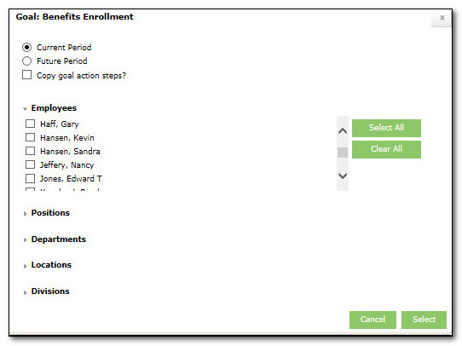

Evaluate Critical Behaviors
(Appraisals > Evaluate Critical Behaviors > Evaluation)
- Select Evaluate Critical Behaviors
- Rate each Critical Behavior
- Add a comment, if desired
- Select Next
- Follow steps (2-4) until Next button turns white
- Confirm complete: Overview/Critical Behavior Progress bar is 100%

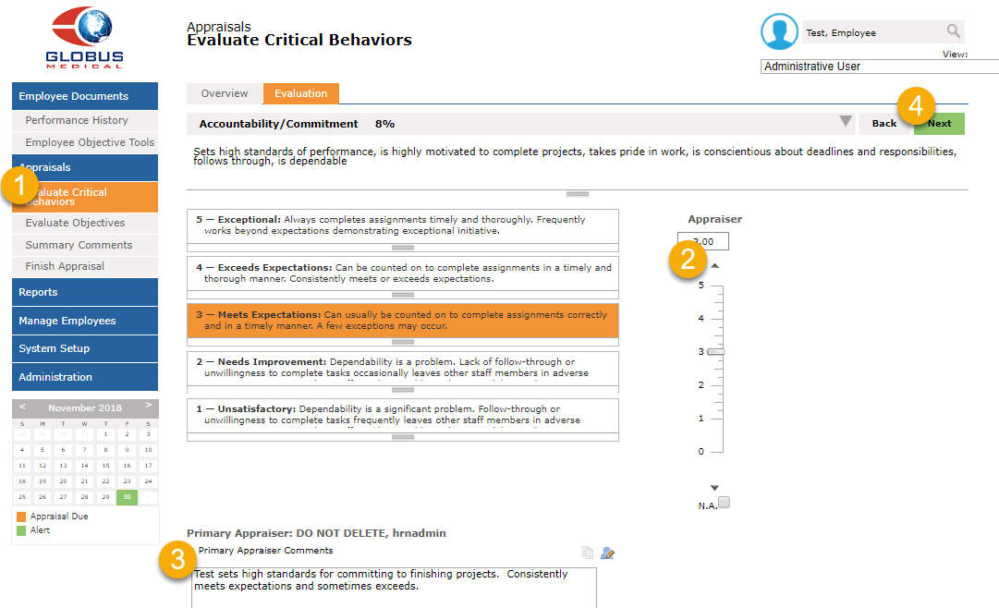
- Comment Coaching. Provides professional, constructive feedback suggestions for appraisers.
- Compare. Allows you compare scores given on the selected Critical Behavior with other employee scores on the same Critical Behavior.
- Spelling and Language Check. Scans the Appraiser Comments for misspelled words or offensive language.

Evaluate Objectives
(Appraisals > Evaluate Objectives > Evaluation)
Evaluating Objectives is as easy as evaluating Competencies.
- Select OBJECTIVE
- Rate OBJECTIVE
- Add Comments, as desired
- Select Next
- Follow steps (2-4) until Next button turns white
- Confirm complete: Overview/OBJECTIVE Progress bar is 100%

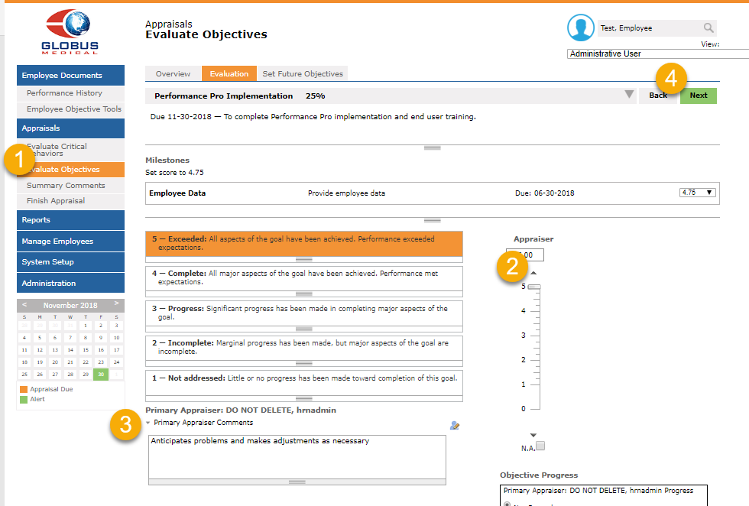

Summary Comments
(Appraisal > Summary Comments)
Summarize performance for the appraisal period. This section is also customizable to fit the needs of your organization, requiring additional information from the appraiser.

Finish Appraisal
(Appraisal > Finish Appraisal > Status Overview)
The Status Overview tab displays the steps that need to be completed in Performance Pro to finalize your employee’s appraisal. However, the system will automatically take you to the Ready, Merge, Route or Complete tab based how much of the checklist you have completed.

Ready
As an Appraiser, marking the Appraisal as Ready signifies that you have completed your first draft of the evaluation. As an Employee, once an Appraisal is marked Ready, it will move into a read-only finalized copy unavailable for future edits. Managers receive an e-mail when an employee completed a self-evaluation.
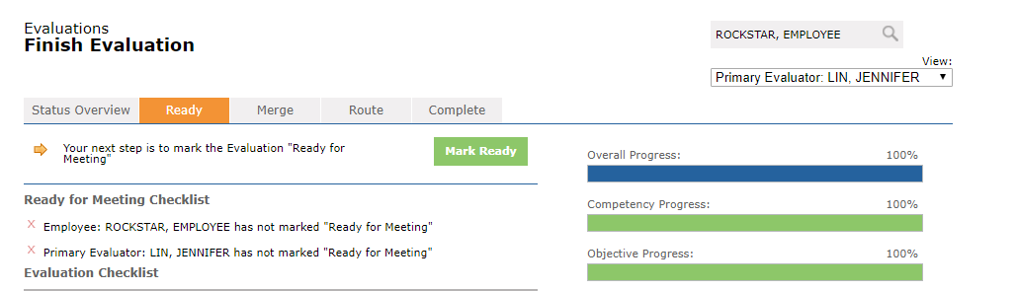

The Appraisal Meeting

- The appraisal meeting should occur in a Timely manner.

- The setting should be Conversational yet Professional.

- Employees should talk 50% of the time.

- Come to an Understanding not necessarily an Agreement.

- Stick to the Observable Behaviors and remove Emotions.

Notes:

Complete
Select Complete after the appraisal meeting with the employee. This is critical step will generate a request for an e-signature from the manager and employee.
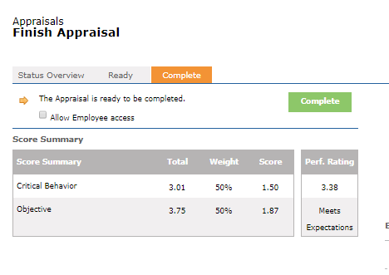

Completing an Appraisal
An Appraisal in Performance Pro can be completed in 5 easy steps.
- Evaluate Competencies
- Evaluate Objectives
- Set New Future Objectives
- Add Summary Comments
- Complete the Appraisal
Notes:

E-Signature
E-Signatures are generated once the appraisal has been marked complete.

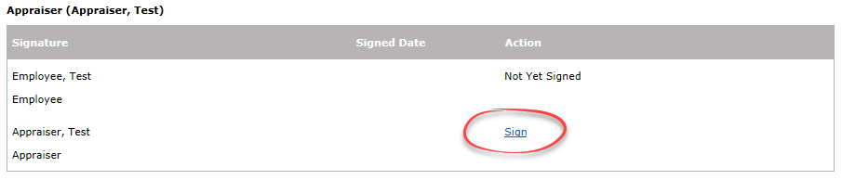
Signature Request for an Appraiser

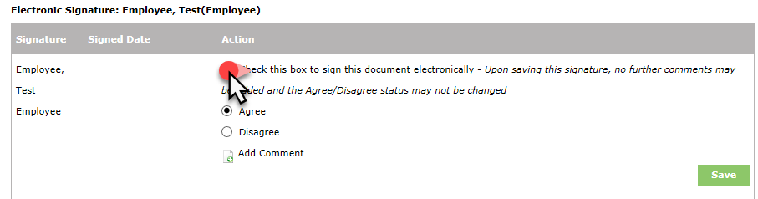
Signature Request for an Employee

Notes:

Widgets & Buttons

Widgets 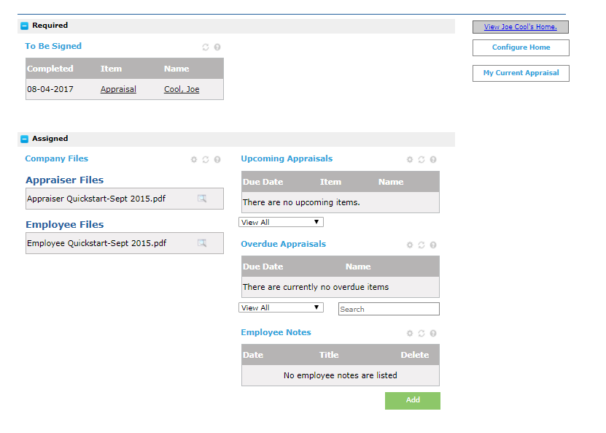
Widgets are the boxes of information available to you on your Home Screen that can be customized and moved based on your organization’s settings. Off to the right, you may find a list of Widgets that you can drag and drop to your Home Screen.
- Welcome Message. Customized message from your organization.
- To Be Signed. Items needing an E-Signature.
- Routing Inbox. Items Routed to you for approval.
- Routing Outbox. Items you have Routed to other people.
- Company Files. List of files available for download.
- Employee Notes. An area where you can track your own personal performance management throughout the appraisal period.
- Peer Feedback: Allows any employee to give feedback to any other employee at any time.

Buttons
- My Current Appraisal. A link to a read only version of your Self-Evaluation if applicable.
- Employee Training. A video training on how to complete a Self-Evaluation (only available if your company has purchased and activated this module).
- Manager Resources. A library of articles that will help you prepare for the appraisal process.

Performance History
Performance History is your employee’s virtual personnel file. It includes current and historical Appraisals, Forms, a place to document performance and an area to attach external documents pertaining to performance management.

Appraisals
(Employee Documents> Performance History> Appraisal Form)
Completed historical appraisals can be accessed and printed at any time from the Appraisal tab. You can also come here to view or print the Current appraisal.

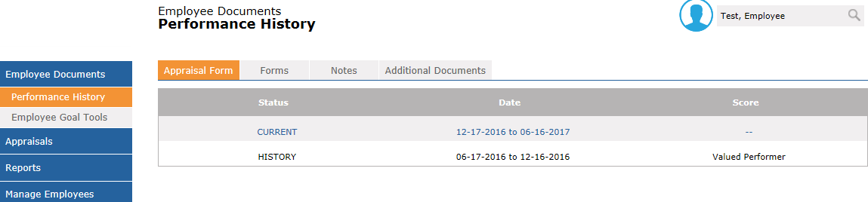

Adding Notes
(Employee Documents > Performance History > Notes)
The Notes section of Performance Pro is designed to assist Appraisers in managing employee performance. As you note the items you would like to remember in the Performance Appraisal, it is imperative that you ensure that the notes are clear and concise. That those that are viewing the note for the first time will understand the situation, the action taken and the needed follow up.
As a reminder, the Employee Notes section on the Home Page is where employees add notes on their own performance throughout the appraisal period that can be used as part of the self-evaluation if applicable. The Notes section in Performance History is where you track details on your employee’s performance throughout the appraisal period.

OBJECTIVE Notes: This is used to update progress toward OBJECTIVE completion.
- Select Employee OBJECTIVE Tools from the Main Menu
- Select the OBJECTIVE to add notes
- Select Notes
- Add notes
- Click Select
- Click Save in the toolbar

Setting OBJECTIVE Progress: This is used to note the progress toward an OBJECTIVE
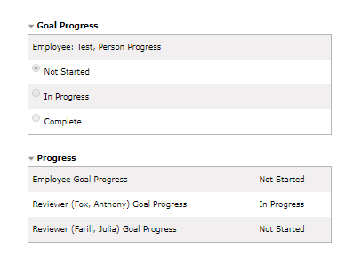
- Select Employee OBJECTIVE Tools from the Main Menu
- Select level of OBJECTIVE progress
- Select Save in the toolbar

Employee Notes: These notes can be used to document successes unrelated to specific Objectives and to share successes with managers.
- Select Performance History/Notes
- Select Add
- Add note content
- Click the Shared button to share with the employee. Notes remain confidential if the note is not shared. It will be accessible by upline managers or administrative users.
- Click Save in the toolbar

Additional Documents
(Employee Documents > Performance History > Additional Documents)
Make Performance Pro your one stop shop for all Performance Management documentation. By loading and storing files in Additional Documents, you are storing things in the “cloud.” Anyone with access to the employee’s file will be able to access the needed files from any computer with an active internet connection.
After selecting the Add New File button, simply enter the required details and Browse out to your computer (like attaching a file to an email). Locate the file you would like to add to the employee’s file and click Upload on the toolbar.
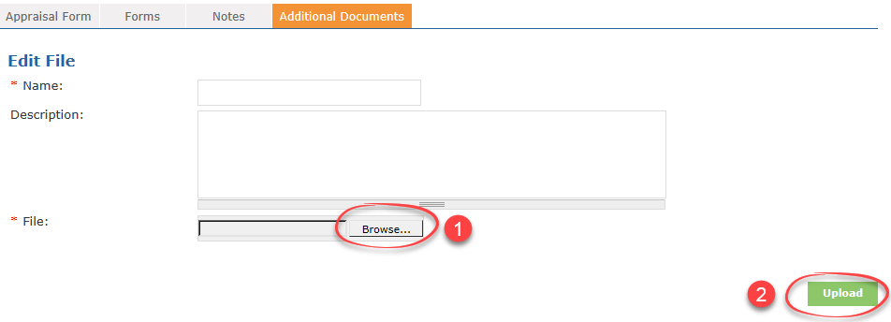
Note:
It is very important when using this section that the files be named with a unique title. Performance Pro will not allow you to have 2 of the same document assigned in the system. Suggested format: Employee Name-Title of Document-Date of document.
Notes:

Wrapping Things Up

Objectives
In the Performance Pro Appraiser Training, we logged into Performance Pro as an Appraiser. You should now understand how to complete an Appraisal using Performance Pro. The key objectives for this training were:
  - Identify the steps of the Appraisal Process
  - Demonstrate the process of completing an appraisal in Performance Pro
  - Discuss how to complete comments on an appraisal
  - Discover the Performance History
  - E-Signing an Appraisal

